Case 8-A470-Can-Vancouver Is-Totem Pole-Thunderbird, Beaver-Mink-mid-20th century

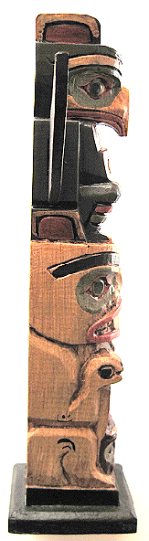 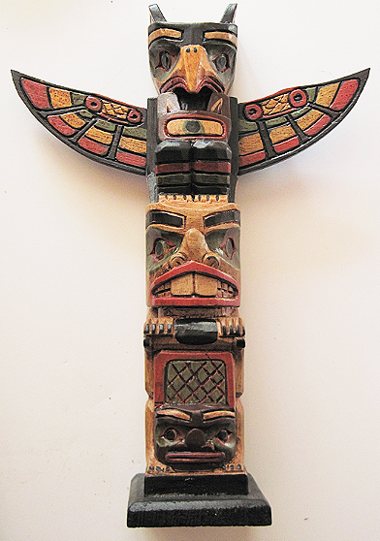 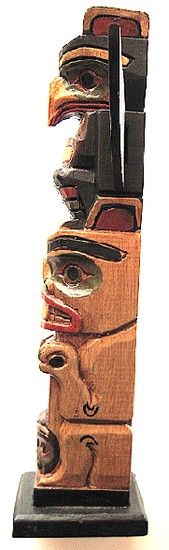

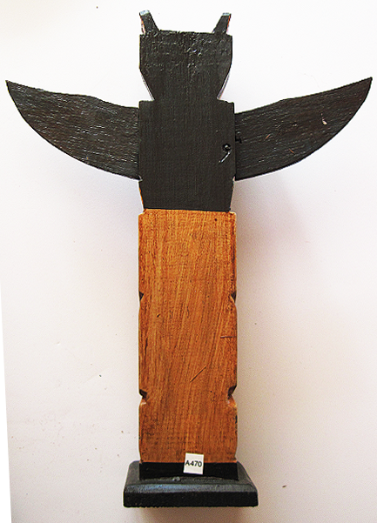

Figs. 1-4. Can-Vancouver Is-Totem Pole-Thunderbird, Beaver-Mink-mid-20th century

**Case no.: 8**

**Accession Number: A470**

**Formal Label:** Can-Vancouver Is-Totem Pole-Thunderbird, Beaver-Mink-mid-20th century

**Display Description:**

The Kwakwaka'wakw combination of the Thunderbird (whose flapping wings sounds like thunder), the Beaver (whose felling of trees crack like thunder) and the Mink (who stealthily hides in the burrows from these sounds) is like an audio message: beware of the cracking of thunder like the mink, it may be real, so be prepared to hide!

**LC Classification**: E99.K9

**Date or Time Horizon:** Late 20th century

**Geographical Area:** Fort Rupert, northeastern Vancouver Island.

**Map, GPS coordinates:** 50º41'51.16" N 127º25'32.09" W

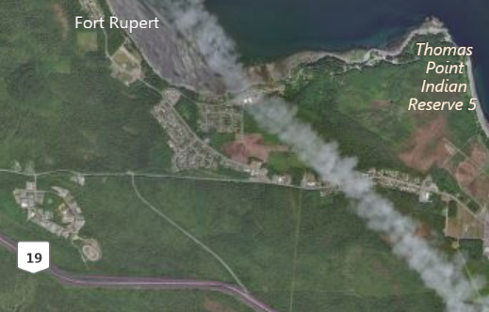

Fig. 5. Map of Fort Rupert and the Kwakwaka'wakw Reserve. After www.bing.com

**Cultural Affiliation:** Kwakwaka'wakw, Kwagu’ł band living at Fort Rupert

**Media:** Wood, Green, Red, Yellow, Black paint, Varnish.

**Dimensions:** H 289.32 mm, 11.39 in; W 224.92 mm, 8.86 in

**Weight: 278 gm, 9.75 oz**

**Provenance:** Kwagu’ł band artist

**Discussion:**

Technically, the style and form of Kwakwaka'wakw totem-poles as well as masks was altered with access to iron tools and supplies made available after contact with early Russian explorers and European settlers (Holm 1965: 5; Malin 1978: 13; Jonaitis 1991: 39, 54; Masco 1995: 42). Northwest Company and the Hudson Bay Trading Company, which built a trading post near Fort Rupert, in 1849 provided contact with other tribes through trade and exchange. Metal carving tools were sharper and more efficient than their traditional lithic counterparts, and modern synthetic paints allowed for more dramatic and durable coloration than did the plant and mineral based pigments previously used (Jonaitis 1991: 39, 54).

However, with all this technological change the role of the past is still evident in the conservatism among some sculptors who refer to historic totem poles and masks in their work. In this respect, historic totem poles are highly valued by the Kwakwaka'wakw as manifestations of ancestral spirits and supernatural beings. Unlike masks these supernatural entities are embodied through erection of totem poles for a select viewing audience (Greenville 1998: 14), and, in addition, individual family groups and individual sculptors vary in their visual expression of different myths and characters (Malin 1978: 47). Since each totem pole is “owned” by particular families and passed down by elders and chiefs to their immediate and extended families, they have a familial conservatism in their local presentation (Gosden and Marshall 1999: 172), which is reflected in the way sculptors create new totem poles (Malin 1978:18-19; Ostrowitz and Jonaitis 1991: 251).

The traditional homeland of several bands of Kwak’wala speakers is Fort Rupert on northeastern Vancouver Island. The Kwagu’ł band living at Fort Rupert has been considered one of the highest-ranked bands, with illustrious lineage from mythic time to the historic present. Their home is a site of strong traditional ceremonialism and symbolism. In 1849, the Hudson's Bay Company established a trading post there, thus promoting Fort Rupert as a *rendezvous* or center for trade and exchange as the most prominent village of the last half of the nineteenth century in the Northwest for exchanging iconographies and myths. George Hunt was raised by his Kwakwaka’wakw mother in indigenous ways but energized by his Scottish father to preserve valuable Kwakwaka’wakw information and hundreds of utilitarian and ceremonial artifacts which he deposited in museums beginning in the 1890s (see Boas and Hunt 1902-1905).

**References:**

Greenville, Bruce. 1998. “Introduction.” In Macnair, et al. 1999, pp. 14-16.

Hawthorn, Audrey. 1979. *Kwakiutl Art*. Seattle: University of Washington Press.

Holm, Bill. 1984. *Form in Northwest Coast Art in Indian Art Traditions of the Northwest Coast*, ed. Roy L. Carlson. Burnaby, B.C.: Archaeology Press & Simon Frasier University.

1972. *Crooked Beak of Heaven*. Seattle: University of Washington Press.

1965. *Northwest Coast Indian Art*. Seattle: University of Washington Press.

Boas, Franz; George Hunt. 1902-1905. *Kwakiutl texts, First and Second Series*. Memoirs of the American Museum of Natural History, v. 14, pt. 1; Publications of the Jessup North Pacific Expedition, v. 10, pt. 1. New York: Knickerbocker Press

Jonaitis, Aldona; Douglas Cole; Stacy Alyn Marcus; Lynton Gardiner. 1991. *Chiefly Feasts: The creation of an exhibition in Chiefly Feasts: The Enduring Kwakiutl Potlatch.* New York and Seattle: American Museum of Natural History and University of Washington Press.

Macnair, Peter. 1998. *Power of the Shining Heavens in Down from the Shimmering Sky: Masks of the Northwest Coast.* Vancouver and Seattle: Douglas & McIntyre and University of Washington Press.

Macnair, Peter; Robert Joseph; Bruce Grenville. 1999. *Down from the Shimmering Sky: Masks of the Northwest Coast.* Vancouver, British Columbia: Dover.

Malin, Edward. 1999. *Northwest Coast Indian Painting: House Fronts and Interior Screens*. Portland, OR: Timber Press.

1978 *A World of Faces: Masks of the Northwest Coast Indians*. Portland, OR: Timber Press.

Masco, Joseph.1995. “‘It is a Strict Law That Bids Us Dance’: Cosmologies, Colonialism, Death, and Ritual Authority in the Kwakwaka'wakw Potlatch, 1849 to 1922,” *Comparative Studies in Society and History* 37 (1): 41-75.

Ostrowitz, Judith, and Jonaitis, Aldona. 1991. “Postscript: The Treasures of Siwidi in Chiefly Feasts: The Enduring Kwakiutl Potlatch” In Aldona Jonaitis, et al., 1991.

Pollock, Donald**.** 1995. “Masks and the Semiotics of Identity,” *The Journal of the Royal Anthropological Institute* 1(3): 581-597.